MIT Assignment-05

Jeetu Mehra
U24AI032

Question 1 : Write a instruction in assemble language to add decimal 12BCD to the accumulator,which contains
39BCD.
Output:

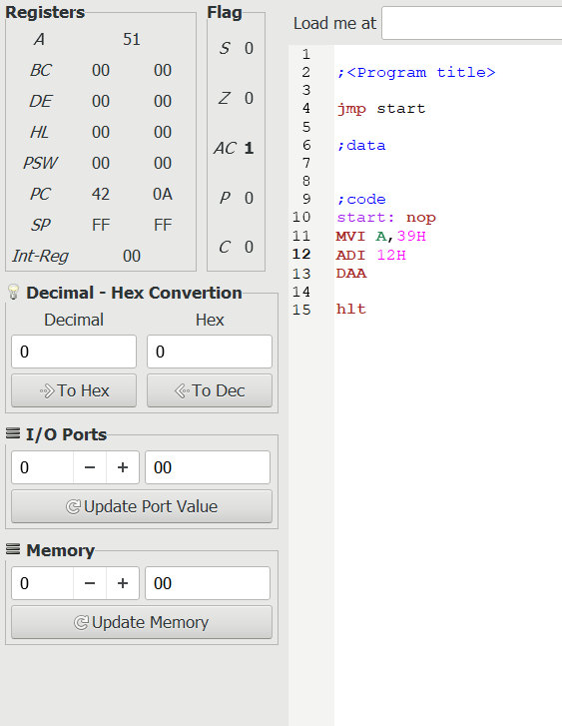

Question 2: Write a instruction in assemble language to add two decimal numbers 85BCD and 68BCD .
Output:
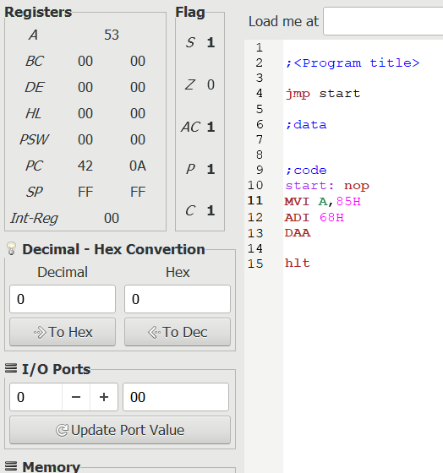

Question 3: Write a instruction in assemble language to add 16-bit contents of the specified register pair to
the contents of the HL register.
Output:
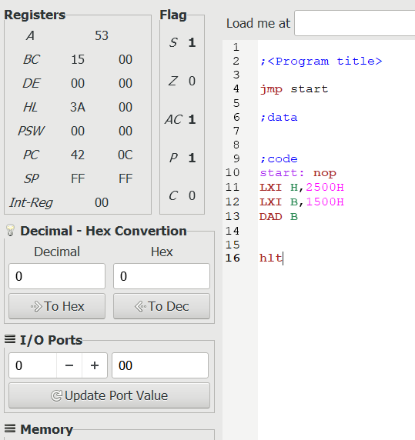

Question 4 : Write a instruction in assemble language to copies contents of pointed 16-bit memory location
in L and contents of next memory location to H .
Output:
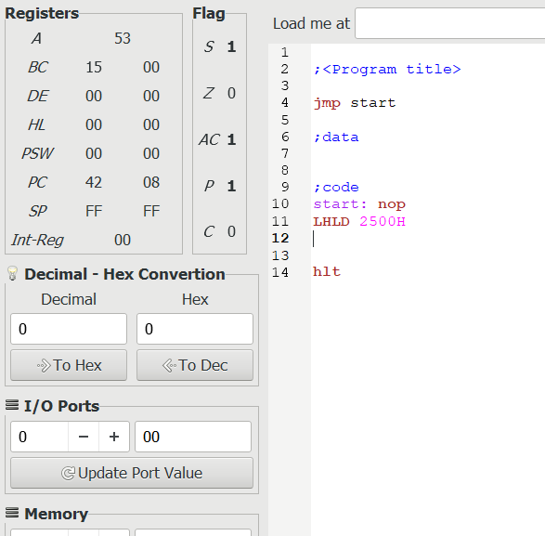

Question 5 : Write a instruction in assemble language to copies contents of registers H and L into the Program
counter.
Output:
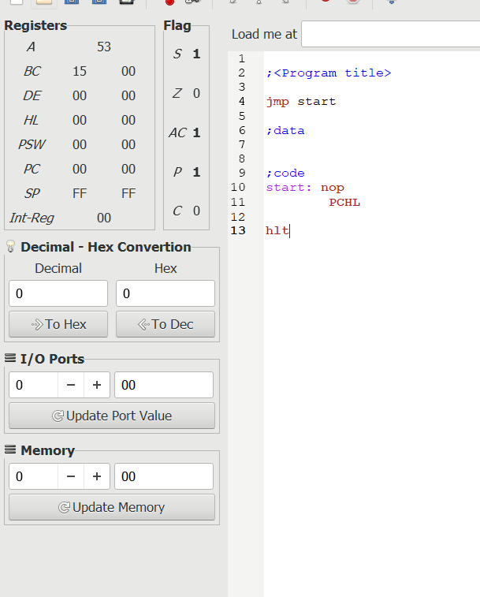

Question 6 : Write a instruction in assemble language to rotate the contents of the accumulator left through
Carry, assuming the accumulator has A7H and carry flag is reset.
Output:
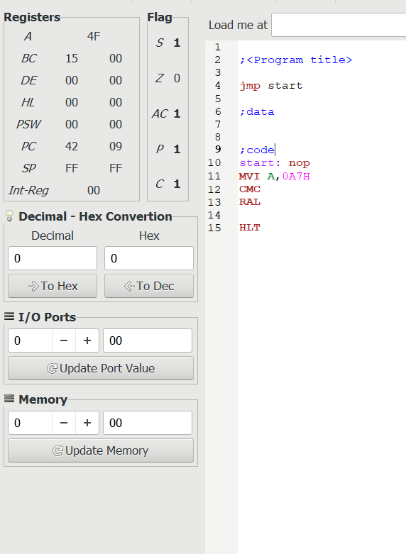

Question 7 : Write a instruction in assemble language to rotate the contents of the accumulator right through
Carry, assuming the accumulator has 85H and carry flag is reset.
Output:
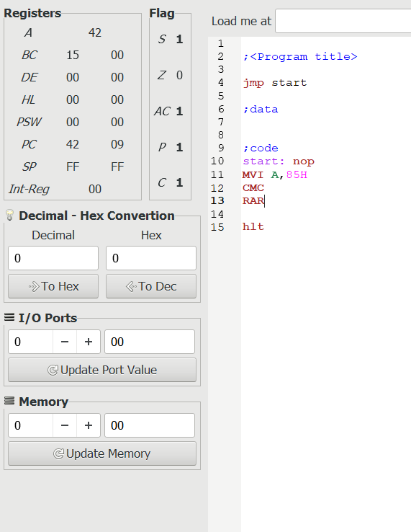

Question 8 : Write a instruction in assemble language to rotate the contents of the accumulator right through
Carry, assuming the accumulator has 77H and carry flag is set.
Output:
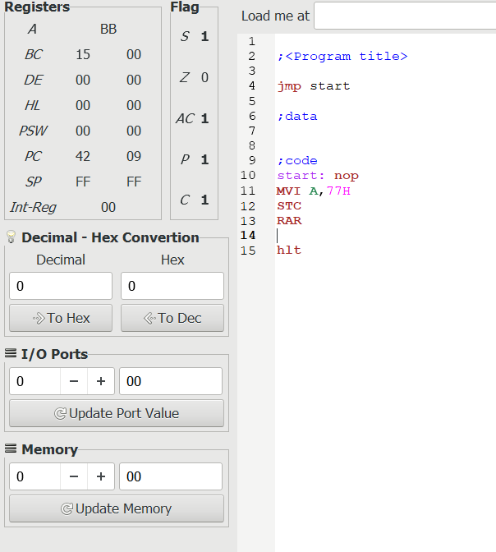

Question 9 : Write a instruction in assemble language to rotate the contents of the accumulator left through
Carry, assuming the accumulator has 65H and carry flag is set.
Output:
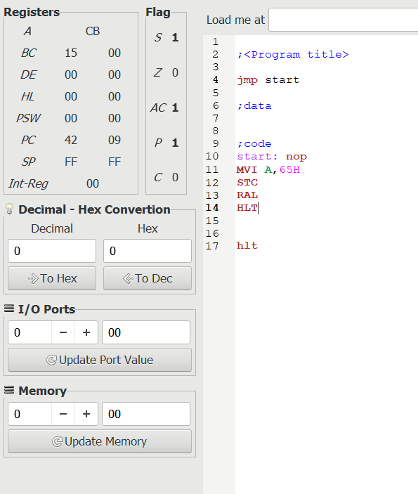

Question 10 : Write a instruction in assemble language to copies the contents of HL pair to specified memory
location.
Output:

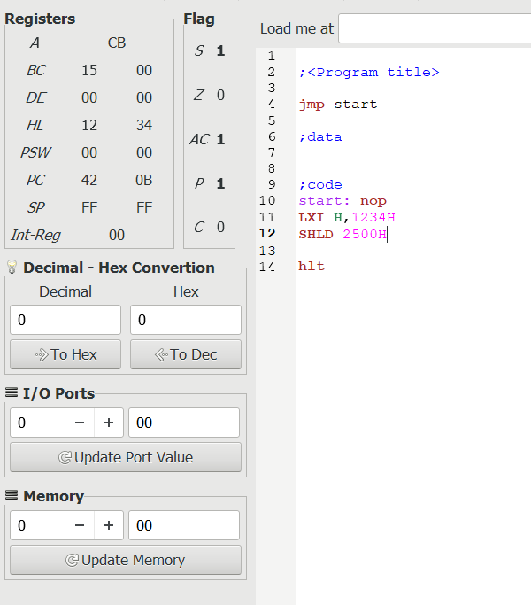
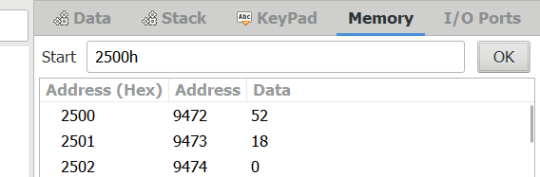

Question 11: Write a instruction in assemble language to copies the contents of HL pair to stack pointer.
Output:
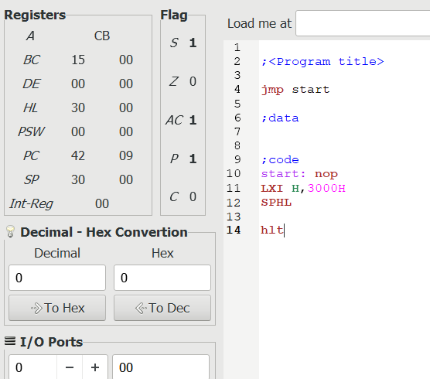

Question 12: Write a instruction in assemble language to set a carry flag.
Output:
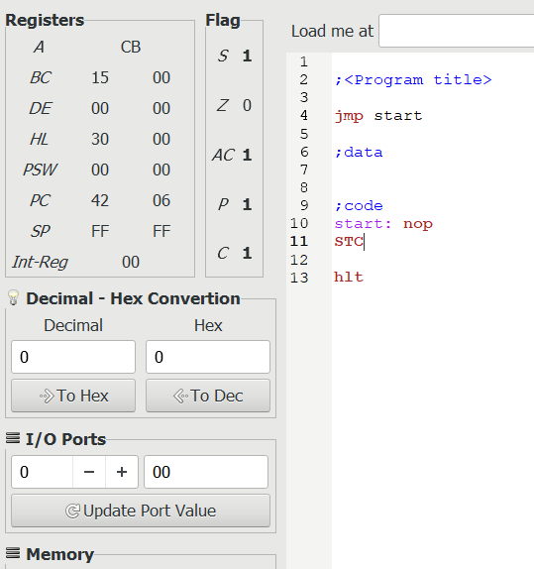

Question 13: Write a instruction in assemble language to exchange the contents of HL with DE.
Output:
